Birla Institute of Technology & Science, Pilani
Work Integrated Learning Programmes Division
First Semester 2024-2025

Comprehensive Exam
(EC-3 Regular)

Course No. : CC ZG506
Course Title : API-Driven Cloud Native Solutions
Nature of Exam : Open Book
Weightage : 35%
No. of Pages = 3

No. of Questions = 6
Duration : 2.5 Hours
Date of Exam : 29-Nov-24 (AN)
Note to Students:
- Please follow all the Instructions to Candidates given on the cover page of the answer book.
- All parts of a question should be answered consecutively. Each answer should start from a fresh page.
- Assumptions made if any, should be stated clearly at the beginning of your answer.

Q.1. Based on the diagram, describe a real-world scenario where you need to apply all the stages of API development. Consider outlining how you would gather and define the requirements for your API, design its structure and endpoints, and configure the necessary infrastructure. How would you implement the development of the API, publish it for developers to use, and test its functionalities to ensure everything works correctly? Finally, explain how you would deploy the API for consumers and provide ongoing support or improvements post-deployment. Let the answer be concise. [8 marks]

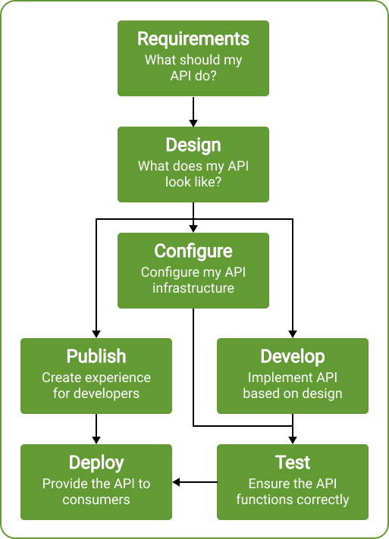

Q.2.
a. Suppose you are tasked with the activity of - "generating catchy marketing slogans or taglines that are creative and diverse, yet aligned with a brand's specific messaging" using LLMs/ SLMs. How would you set the "temperature" and "top_p" hyper parameters for this scenario? Justify your answer. [2 marks]
b. You are a data scientist and are using an LLM-based tool to generate an in-depth analysis report on a dataset, including statistical findings, visualizations, and interpretations. How would you set the "temperature" and "stream" hyper parameters for this scenario? Justify your answer. [2 marks]

Q.3. Challenge the accuracy of the below statements (agree/disagree) with short justification. [Answer should contain few bullet points of no more than 2 - 4 lines]. [4 marks]
a. Sentiment Analysis involves "Named Entity Recognition" as an internal step in the processing.
b. Recommendation engines can be categorized under "predictive analytics".

Q.4.
a. Identify the errors in the dockerfile and rewrite the same correctly [3 marks]
FROM python:3.8-slim
WORKDR /app
COPY . /application
RUN pip install --no-cache-dir -r reqs
EXPOSE 80
ENV NAME World
CMD ["python", "app.txt"]

b. Suppose some developer has designed a custom docker image named “restappimage:latest” for a RESTful Web Application, and deployed the same on DockerHub. What docker commands would you use to run this image locally? Correlating with the docker architecture, explain the steps in detail. [4 marks]

Q.5. Imagine that you are an AI Cloud Engineer tasked with developing an API-based AI Chatbot that answers questions based on internal enterprise documents, such as technical manuals or policy documents. Outline two approaches you would use to implement this solution. Specify the APIs you would use for each approach and explain any assumptions you make. Code is not required.
[7 marks]

Q.6. A user provides the following prompt to an SLM - "Who is the founder of C++?" and the SLM responds as "The founder of C++ is Bjarne Stroustrup".
a. If we assume that every word is considered as a "token", and the cost of every token is $0.0001, calculate the cost of using the SLM API. State your assumptions clearly, if any. [3 marks]
b. Under what situation(s) will the SLM respond as "Context does not contain the expected answer"? [2 marks]

***********

